Table of Contents

Adapted Frayer Model Vocabulary Graphic Organizer 2

Key Word Web 3

Parts of Speech Vocabulary Record GO 4

Curriculum Vocabulary Collection Instructional Program 5

Related Words Vocabulary Instructional Program 6

Curriculum Vocabulary Planner Chart 7

“What I Know”: Instructional Program 9

“What I Know” Graphic Organizer 11

Topic Knowledge Assessment Activity 11

Text Clues Graphic Organizer 11

Word Shapes Graphic Organizer 13

# Adapted Frayer Model Vocabulary GO

I look up “word + kids definition” to find the most basic definition, hopefully with words the student already knows.

Here you try to find connections to what the student already knows or prior experiences.

Can pick together from Google images. Sparklebox.co.uk also has fantastic images.

Look for tier 1 (some 2) words that really emphasize the concept. This can also be a good place to add in objects that you can associate with the word.

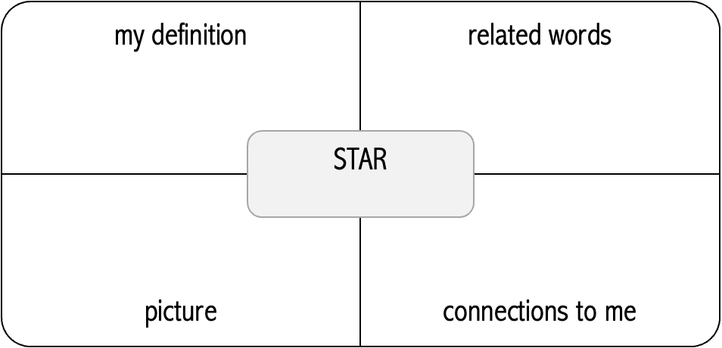

big, bright, ball in the sky

sun, sky, up, hot, move, look/see, night, many, far, telescope

I read a book about stars.

I see stars at my house.

I saw stars at the science museum.



# Key Word Web GO

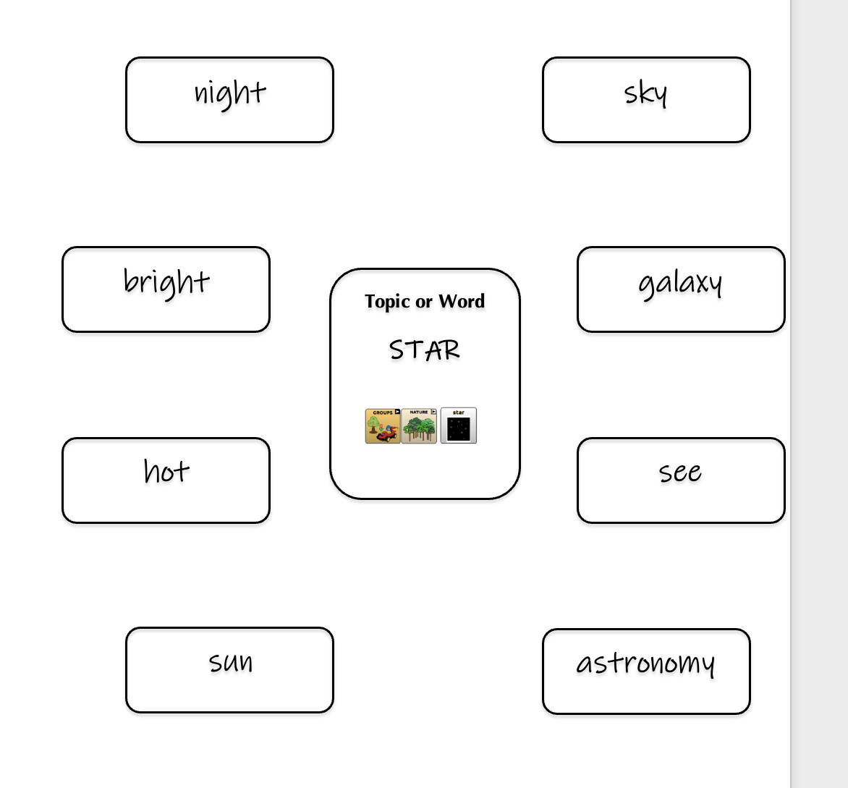

# Parts of Speech Vocabulary GO

|  |  |  |  |  |  |  |  |  |
| --- | --- | --- | --- | --- | --- | --- | --- | --- |
| people | |  | actions | |  | places | | |
|  |  |  |  |  |  |  | |  |
|  |  |  |  |  |  |  | |  |
|  |  |  |  |  |  |  | |  |
|  | | | | | | | | |
| descriptions | |  | things | |  | other | | |
|  |  |  |  |  |  |  |  | |
|  |  |  |  |  |  |  |  | |
|  |  |  |  |  |  |  |  | |

|  |  |  |  |  |
| --- | --- | --- | --- | --- |
| ANCIENT EGYPT – Priority Words | | | | |
| mummy | pyramid | river |  |  |
| Full Set of Vocabulary from Curriculum | | | | |
| things | people | places | actions | descriptions |
| **MUMMY** bandages  cloth  body | King  Tutenkhamen  Pharaoh Egyptians | Egypt | wrap  cover  protect | around  old |
| PYRAMID  triangle  stones  sand  treasure  pottery | mummies  slaves  kings  guards | Egypt | build  push  pull | up  big |
| **RIVER**  water  fish  rocks  land  Nile  line |  | Egypt | move  flood  flow | up  down  over  fast |

# GEC Vocabulary: Collect and Prioritize Plan

|  |  |
| --- | --- |
| Class | *Class or subject area; Topic or theme* |
| Topic Vocabulary | *List of topic vocabulary.*  Indicate if a list is attached, or you can record the words in the space provided.  These are words that represent the concepts, knowledge and skills that are associated with this topic  Reference available resources for information about the topic as needed:   * Teacher’s lesson plans * Google “(topic) for students” or “(topic) vocabulary” * Sparklebox.com Word Mats (1-page topic-specific displays of words plus images) |
| Class Priority | *If available, indicate (underline or asterisk *) any words that the classroom teacher says will be the most important.* |
| Priority | *Select UP TO 5 key words that will be used as the foundation of instruction for this topic. Circle the words from the list (above) and/or write them in the space provided*  Helpful guidelines for prioritizing vocabulary:   * Quantity: Decide, based on timeline of topic, how many words to target. If the timeline is very short (e.g. reading a book for a day or two) you might stick to focusing on a more general set of vocabulary learning (e.g. core vocabulary) * Importance: Identify words that are important to the topic and to the classroom instruction * Interest: Consider area(s) of interest within the topic for the student (e.g. mummies, river, maps etc.) as a potential focus * Complexity: Consider what “Tier 1” words might be associated with the key word that would benefit the student. |
| Key Vocabulary Plan | *Lastly, complete a “Key Vocabulary Planner” form for the selected vocabulary.* |

# GEC Key Vocabulary Plan

|  |  |  |
| --- | --- | --- |
| Key Vocabulary Word: | One of the curriculum vocabulary words identified as a priority focus for student learning. | |
| Topic: | Title of curriculum unit or topic | |
| Related Words: | In the chart provided (or as a list), identify words that could be used to describe the key word, or that are associated with the key word. These related words are the real focus of instruction because of their usefulness and frequency of use. While the key words are the ones connected to the topic, the concepts and knowledge are captured by these supporting words.  Based on the vocabulary words selected, identify different parts of speech that:   * can be used to define the word * “go with” or are associated with the word * are examples of the word * represent less complex terms   Start with the key word, term, or concept (e.g. “Ancient Egypt”) and express that in broad terms (e.g. “old place”). Try to have a balance the words represented: Aim for 20% fringe words (more topic-specific, generally Tier 3) vs. 80% core words (more general, Tier 1) and include different parts of speech. Use the Core Vocabulary Planning Chart to help guide you to Tier 1 words. Use the questions below to help generate different parts of speech. | |
|  | Nouns: | What are the parts?  What things are related? |
|  | Actions: | What does it do?  What actions are related? |
|  | Description (sensory): | What size is it?  What color is it?  How does it feel?  What shape is it?  Does it have a smell? |
|  | Features: | How does it move?  How does it behave?  Who is connected to the word?  What places are related? |
|  | Categorization: | What belongs with it?  What is it like (similar to)?  What is the opposite? |
|  | | |
|  | | |
| Related Objects:  Based on the key word and related vocabulary above, brainstorm objects that could represent different words, concepts, etc.   * Using the brainstorm list of objects, gather the topic items. * Look for diverse, interesting, engaging materials * Try to use a variety of textures and materials – stay away from miniatures or plastic replicas * Think about things the student could “do” with the items to reinforce the meaning of the vocabulary | | |
| Related Experiences / Personal Connections:  Think about the ways that the words above connect with the student. Think about their family, events in their lives, school interactions, student preferences etc. What experiences have they had that you could reference when teaching specific words? | | |

# GEC Key Vocabulary GO

|  |  |  |  |  |  |
| --- | --- | --- | --- | --- | --- |
| Topic |  | | | | |
| Vocabulary Word | things | people | places | actions | descriptions |
| Topic Word |  |  |  |  |  |
| Related words: | | | | |
| Related objects: | | | | |
| Experiences / Connections: | | | | |
| Examples and Non-Examples | | | | |

# Diagram Description automatically generated“What I Know” Instructional Program

Topic Knowledge Assessment Activity

|  |  |
| --- | --- |
| Introduction | *These instructions will be appropriate for students who can communicate effectively using speech, sign, writing, typing, AAC device, or robust AAC book.* |
| TARGETS | The outcomes of this activity are:   * find out what the student may already know about a topic * collect baseline data on student’s topic knowledge |
| TOOLS | The materials needed to complete this activity are:   * blank “What I Know” graphic organizer (or class version) * Writing tool (marker, pencil, pen etc.) * AAC device (if student has one) |
| TEACHING | The steps to completing this activity are below. |
| 1. Identify Work | Label page with date, student name, topic, and instructor. Include notes about how the student communicated their responses if relevant. |
| 1. Communication Tools | Make sure student has their general communication supports. They should not have any instructional materials related to this topic at this point. |
| 1. Instructions | Show the student the topic name in writing and say:  “I want you to tell me what you know about (topic).”  “What are some words you know about (topic)?”  “You tell me, and I will write them down” |
| 1. Student Response | Student should generate words using their typical communication mode. Do not guide the student, in any way, or indicate if their responses are right/wrong during this assessment. |
| 1. Recording Responses | You can repeat the word the student generated. Unless the student is writing their own answers on the page, scribe their words (spoken or on AAC device) onto the graphic organizer. |
| 1. Pause Time | Pause and look expectantly at the student for the next word. If the student says very little, you can encourage them by saying “What else do you know?” or “What else can you tell me?” |
| 1. Completion | When the student indicates they are done, make any notes about the assessment process on the page. Take a photo of the completed page for student’s file |
| TESTING | This activity is an assessment, so no other progress monitoring is needed. |
| TEAM PREP | Gathering materials is the preparation required. |

# Diagram Description automatically generatedDiagram Description automatically generated“What I Know” GO

Topic Knowledge Assessment Activity

What I know about _______________________

“Tell me what you know about (topic).”

“What words go with this (topic)?”

“What does this mean to you?”

Scribe each response without right/wrong

Repeat at start end end of instruction. feedback.

Student: ___________________________ Instructor: ____________________________ Date: _________________

Prior instruction on topic: ___ yes ___ no

Student: ___________________________ Instructor: ____________________________ Date: _________________

# Text Clues Graphic Organizer

Prior instruction on topic: ___ yes ___ no

Text clues about _______________________

“Let’s look in your book to find out about (topic).”

Scribe words/phrases found in text features: graphics, titles, charts, labels, etc.

Student: ___________________________ Instructor: ____________________________ Date: _________________

Prior instruction on topic: ___ yes ___ no

Student: ___________________________ Instructor: ____________________________ Date: _________________

Prior instruction on topic: ___ yes ___ no

# Key Word Class Activity

***Purpose***:

* Show student others using her SGD
* Teach peers about vocabulary and navigation on SGD
* Enhance student learning of curriculum vocabulary
* Demonstrate connection between SGD and curriculum (adults)

***Materials***

* index cards
* tape
* paper
* SGD

***Steps***:

1. Identify a current curriculum topic or theme
2. Select 5 key words (number to be adjusted based on implementation)
3. Write out each work on a separate paper
4. Ask students “what are some words that go with this one?”
5. Students can write their word on an index card
6. Student navigates to word on LAMP
7. Student tapes the word on the page with the key word.

***Options - Variations***

1. Encourage different types of words (not just tier 3 but more basic words to connect to the theme or concept). Any word that the student says is acceptable as long as the student can say why the word is connected.
2. Option for students to write the sequence used to get to the word. If the word is not in the device encourage them to find a word that means the same thing.
3. Optional format is for key word/term to branch off into specific parts of speech (noun, verb, describing, location) so students think of words to fill in missing parts until the entries are full
4. Option to post word pages each week.

# Word Description Shapes GO

By Speak For Yourself

