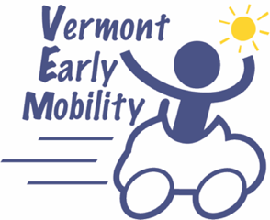 |  | VERMONT EARLY MOBILITY TIP SHEETS

ACCESSIBLE RECESS

GENERAL IDEAS

Build a music wall
- Collect junk as your instruments: muffin tins, tin cans or mugs, colanders, or hubcaps. Use cutlery for wind chimes.

Create a dramatic play station
- Where do you want to go today? Try different scenarios, such as a lemonade stand, food truck window, or vet’s office.

Play Tag games
- Pool Noodles! These can be cut and used to increase the reach of a student in a wheelchair. Pool Noodles can be attached to a wheelchair or other mobility device, so the student doesn’t have to use their hands or arms. All students can use Pool Noodles. (Pre-teach safe tagging).

Work at Elevated Sand Tables
- Ideal for providing sand and water sensory experiences in a garden or playground: Make sure there’s space next to and underneath the table for wheelchairs and other mobility devices.

Play Ball Games
- Use a variety of objects and balls: bean bags large and small, balloons, beach balls, textured balls, balls that make sounds, balls that have lights.
- Play pool noodle soccer or hockey: You can attach the noodle to chair or mobility device!
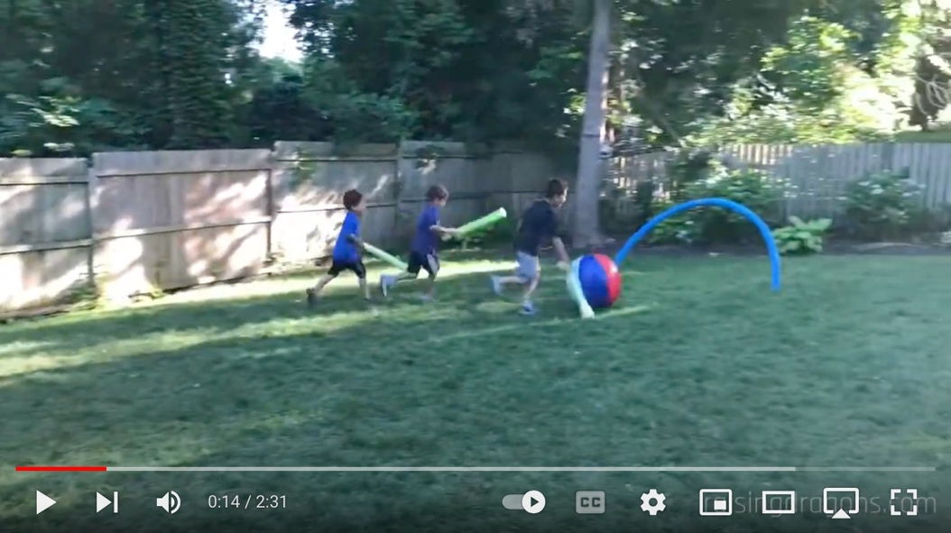

- Change the height and distance of targets for throwing games: play cornhole, or use a clothesbasket on a bench for beanbag toss. Hang a low basketball hoop.
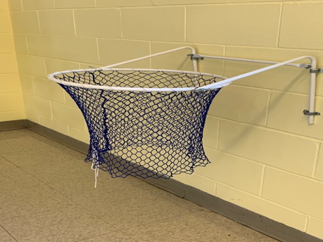

- Explore bowling: use a ramp or throw a ball; think of fun things to knock down! Or use a piece of plastic gutter as a ramp. This is also a tool for racing toy cars.
- Create tools: to play catch with smaller balls/bean bags. A milk jug can be cut open, and the student can use the jug handle to catch. The size of the jug and the hole can be varied. The jug can be attached to student’s chair.

Create Chalk Drawings
- Outdoor walls and surfaces are great surfaces for chalk.

Blow Bubbles

Go on Scavenger Hunts and Nature Walks

TABLETOP ACTIVITIES
Ensure the playground has a picnic table, or other form of outdoor table, with adequate space for a student to wheel up to and share the surface with peers.

Activities could include: board games, puzzles, arts and crafts, card games, social games.

WINTER-SPECIFIC IDEAS
Preparation: Plow the basketball court (or similar defined open area) and the path to it, to allow an accessible area of play. Plow a path to the picnic table.

Equipment:
- Place a tray on the student’s lap for snow play.
- Use an adapted sled; include/invite peers to pull or push.

Activities:
- Snow art: use colored water in a spray bottle; peers can join in or help
- Snow gardening; use garden tools and fake plants to make a garden (ex: wheelchair user can use a pool noodle to create holes for plants, or even point to where plants should go)
- Repurpose sand toys
- Snowball toss – into buckets
- Snowball bowling

- Snow person making (ex: wheelchair user can help build a
head on their lap)
- Invite peers for an indoor activity if it’s too cold outside

Additional activities:
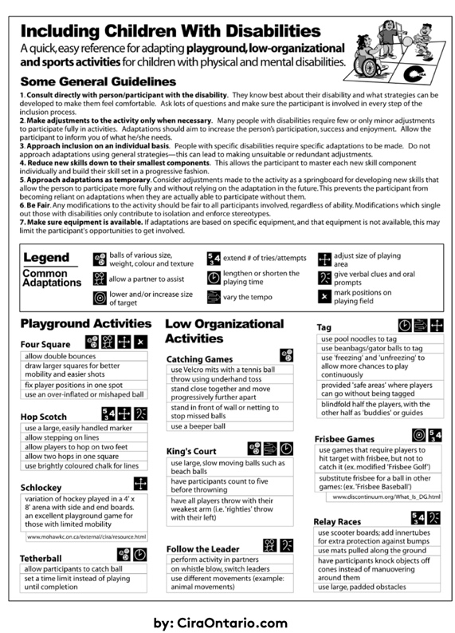
1. Click or tap for the full-size version

This worksheet by CiraOntario.com features a number of great ideas for inclusive play, all in one place. All information is copyright CiraOntario.com and is provided here for informational use only.

INCLUSIVE PLAYGROUND RESOURCES
- ADA checklist (.pdf)
- Inclusive Playgrounds
- Landscape Structures
- Oakledge for All: Building an Accessible Playground (video)

